MOVIE RECOMMENDER SYSTEM
DEPARTMENT OF INFORMATION SYSTEMS
UMBC

Sushmitha Macheri Prachi Mardhekar Tanvi Kulkarni
nagasum1@umbc.edu prachim1@umbc.edu t66@umbc.edu

ABSTRACT
Many people now like to watch television shows or series whenever and wherever they want. Digital TV has grown exponentially in recent years.To be exact, with respect to Deloitte's Digital Democracy Report, which is an annual survey of improvements in the digital environment, 49% of U.S. households subscribe to one or more streaming video services in 2016, compared to 31% in 2012. Apart from the time-management advantages that digital TV offers to viewers, another reason people often choose streaming and on-demand TV is the lack of commercial breaks, the freedom to watch where they want, the phone they want and the ability to find new content. Netflix is one of the participants in the domain of streaming services online.Netflix, founded as an online video store in 1999, has become the most widely used and an American online streaming service specializing in video-on-demand distribution which is still growing. Currently, they are active in over 190 countries all over the world with over 100 million subscriptions. Recently, the number of U.S. Netflix streaming has exceeded the number of daily subscription cable TV subscribers, see Figure. 1. Every day, Netflix streams over 125 million hours of video, and the number of titles continues to rise.

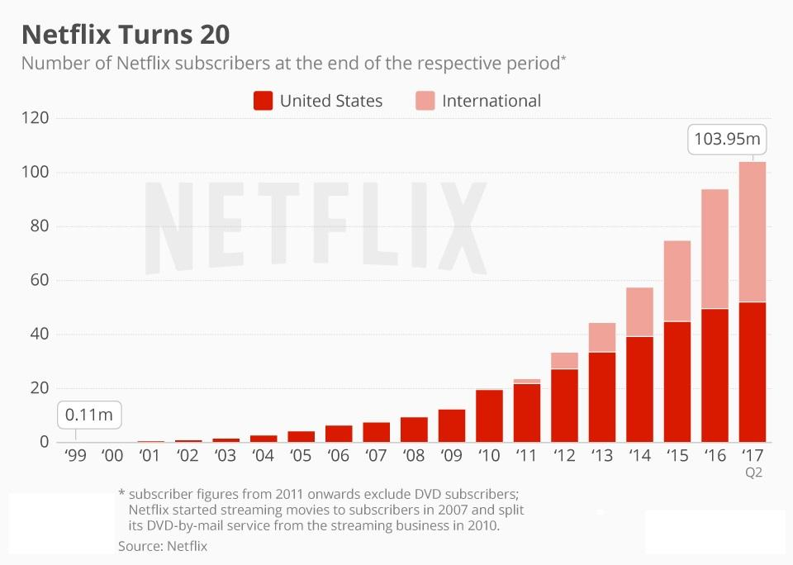

It can be inferred from these statistics that Netflix gathers a lot of data that can be used in several ways. For example, they can analyze data to increase the revenue, for marketing purposes, and to improve their customer satisfaction.Recommendations based on the behavior of the user have played an important role in e-commerce customer satisfaction with regard to customer satisfaction in general.Most online shops, such as Amazon and Alibaba, use recommendation strategies to suggest products for their users that are identical to the one they've been searching for, or they've recently purchased. In addition, recommender systems are also commonly used by online travel companies such as booking.com and Expedia, enabling travelers to discover their ultimate destination match based on their search activity, previous reservations, or similar users. In reality, in all kinds of industries, recommender systems are used due to the enormous data-driven world in which we live today.In addition to the growing number of social media platforms, all of which produce vast amounts of data, users' need to customize content has played an important role in the growth of recommender systems. Netflix not only uses recommender systems to improve customer satisfaction, but also because customers choose between multiple choices that are poor.From consumer research conducted by Netflix, it indicated that after 60 seconds of choosing or analyzing more than 10 to 20 titles in depth, an average Netflix customer loses interest.Therefore, over the years, Netflix has developed a recommender framework, which consists of various algorithms combined into an ensemble process.Therefore, over the years, Netflix has developed a recommender framework, which consists of various algorithms combined into an ensemble process.

INTRODUCTION
Most of the web products we use today are driven by recommender systems.YouTube, Netflix, Amazon, Pinterest, and a long list of other internet services all have recommendations for filtering millions of content and making personalized recommendations to their users.Recommendation programs for businesses and their clients are well studied and proven to provide significant values.In 2009, Netflix awarded a $1 million prize to a technology team for an algorithm that improved the reliability of the company's recommendation system by 10%.The project's aim was to develop a recommender system based on Netflix data.Netflix is a company that handles a large collection of TV programs and movies by streaming it online (computers or TV) at any time. This company is profitable as users make a monthly payment to access the platform.At any time, however, customers can cancel their subscriptions. Therefore, keeping users hooked to the site and not losing their interest is essential to the company. Recommendation systems are starting to play a major role as providing valuable feedback to users is crucial.The research was based on real data from the consumers of Netflix and the scores they provided to the films they watched.

BACKGROUND
A recommendation system is a subclass of information filtering system that attempts to predict a user's "rank" or "preference" of an element. We are used mainly in commercial applications.Recommenders are used in a variety of areas and are most widely known as video and music services playlist creators such as Netflix, YouTube and Spotify.
The idea is basically to recommend users the most popular movies.These might be the most watched, or those with the highest ratings.These might be the most watched, or those with the highest ratings.The recommendations for popularity can be generated on the basis of usage data and content of objects. Surprisingly, such an approach usually affects the actions of the client. In news sites, for example, where articles such as "Popular News" are present and then subdivided into sections.The recommendations for popularity can be generated on the basis of usage data and content of objects. Surprisingly, such an approach usually affects the actions of the client. In news sites, for example, where articles such as "Popular News" are present and then subdivided into sections.It's particularly useful when the user is new to the system and hasn't watched or rated any movie, that is, if we don't count on client information.However, we end up with few opportunities to learn by recommending the most popular items, that is, the system won't recommend new items and won't learn from past suggestions. Furthermore, the list of recommendations may remain the same. Collaborative filtering or content-based filtering are some more complex methodologies.

RELATED WORK
Since recommender systems are such a hot topic in recent data science research, in the field of recommender systems, many scientific articles have been published. Several relevant works that have been published will be discussed in this section.Recommenders can be classified into roughly three groups: cooperative filtering, content-based filtering, and hybrid filtering. Collaborative filtering is a recommendation strategy that focuses on the user's interest by using other similar users ' preferences. The psychology behind this approach is that if user 1 and user 2 can be assumed to have the same interestsIt determines the most associated users, similar to the target user, based on all data. Such neighbors are close because they have common interests in statistics. Several statistical techniques are used to determine these so-called neighbours. Lastly, for the target consumer, the top n most related products are recommended.The collaborative filtering algorithms based on memory are also called collaborative filtering algorithms based on the user. Sparsity and scalability are the advantages of user-based collaborative filtering. Most recommenders use information with many users and products, but with very few individual ratings.Collaborative user-based filtering uses only the information needed to reduce runtime. Model-based collaborative filtering provides a user rating model for the first time. To do this, it uses many methods in machine learning, such as approaches in clustering, rule-based approaches and Bayesian network.Each of the machine learning techniques uses its own approach. The model of clustering formulates cooperative sorting as a classification problem, while the model of the Bayesian network treats it as a probabilistic system and the model based on rules as a model of association law. The collaborative filtering algorithms based on the model are also referred to as collaborative filtering algorithms based on objects.

METHODOLOGY
Recommenders can be broadly divided into three categories: content-based systems, cooperative methods of filtering, and hybrid systems. The content-based approach uses an object's various features to recommend additional items with similar properties.Collaborative filtering method creates a model based on a user's past actions (items already purchased or selected and/or numerical ratings given to those items) and other users ' related decisions. The model will then be used to forecast items (or ratings of items) that may be of consumer interest.The hybrid approach has incorporated the previous two approaches. In their growth recommendation systems, many companies are likely to use a hybrid approach. We will implement the most common approach in our project, collaborative filtering.Collaborative filtering works on the interactions that users have with items. Such experiences can help to determine trends of the site information. Collaborative filtering does not allow features to be identified about the products or users. It is ideal for a collection of various types of items, such as the stock of a store where items in different categories can be added.
Nonetheless, established features such as writers and styles can be useful in a collection of similar items such as a bookstore, and could benefit from content-based or hybrid approaches.Collaborative filtering can allow recommenders not over-specialize in the profile of a client and recommend products that vary entirely from what they have seen before. If you would like your recommender not to suggest a pair of sneakers to someone who has just purchased another similar pair of sneakers, then try to add cooperative filtering to your recommender code.While collaborative filtering is commonly used in recommendations, some of the challenges faced when using it are as follows: collaborative filtering can lead to problems such as cold start for new items added to the list. They are not recommended until somebody rates them.
The sparsity of data can affect the quality of user-based recommendations and add to the cold start
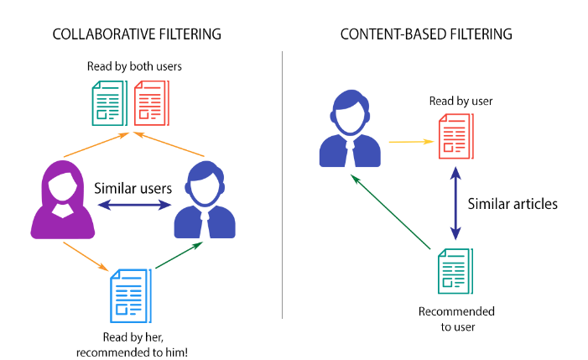

DATASET DESCRIPTION
The dataset used in this project is released by Netflix and is called Netflix Prize Data. Netflix actually used this dataset for a competition they hosted to find the best algorithm to predict user ratings for films. It can be found at- - https://www.kaggle.com/netflix-inc/netflix-prize-data
This dataset has 2 files - Customer file and Movie file. Each of these files have information like customer ID, rating, date, movie ID, movie name and date of release. The dataset used in this research comes from an open machine learning competition, called the Netflix Grand Prize.This competition started in October 2006 and lasted till 2009. The main goal of this competition was to find a more accurate movie recommendation system to replace their current system, called Cinematch. The dataset contains a total of 100,480,507 ratings, based on 17,700 movies which come from a total of 480,189 users from the United States.Of each movie, titles and corresponding year of release were available. Besides, every movie had a unique movie ID, which was a sequence from 1 to 17,700. One must note that the movie ID does not correspond to actual Netflix movie IDs or IMDb movie IDs.In addition, the release year may not match the theatrical release, as the film ID provided corresponds to the release of the DVD. Finally, the titles are always in English and may not suit the titles used on other pages. In Table 1, the film data structure can be obtained by viewing the film data for the first 5 films. ID of the movie.

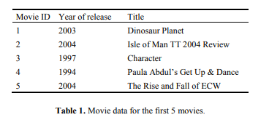

Next, a text file was given for each film, consisting of a user's rating for the particular film, the rating date, and a user ID. You can get a snapshot of the first five ratings in Table 2, which corresponds to the first movie ID (for the Dinosaur Planet movie)

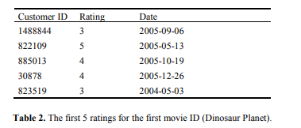

It should be remembered that the area of customer ID is not a series but has gaps between them. In addition, a client may assign scores to a movie ranging from 1 to 5 stars. 9 Another important point is the data available for each customer: Netflix has only agreed to provide every customer with a randomly assigned customer ID, anonymize the data and protect the privacy of their customers.

MODEL DESIGN
Collaborative filtering and Pearsons’ R correlation were the 2 models used to implement the movie recommender system.
Collaborative filtering uses the past behaviour of the users and does not depend on the context at all. It analyses the similarity in taste and preferences of 2 users and provides recommendations based on that. For eg, if user A has watched movies 1, 2 and 3 and user B has watched movies 2, 3 and 4, there is a high possibility that user A will like movie 4 and user B will like movie 1. Therefore a collaborative filtering model would recommend them to the users.
Using our dataset, we have chosen a particular user by their Customer ID, analyzed their rating pattern and provided them with a list of movies that they would like.

Pearsons’ R correlation is a measure of the strength of the linear relationship between two variables. We have used Pearsons’s R correlation between review scores of all pairs of movies and display the top 10 movies with the highest correlation.

EXPERIMENTAL RESULTS
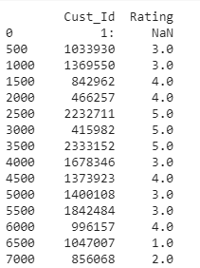
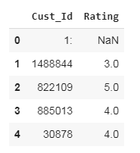

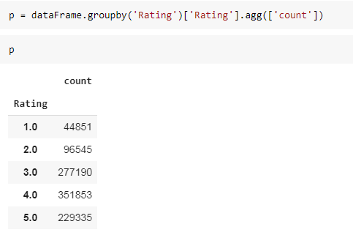
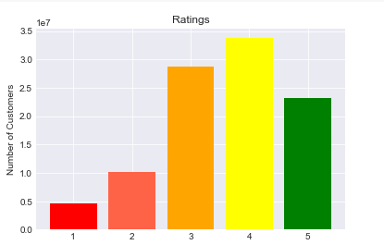

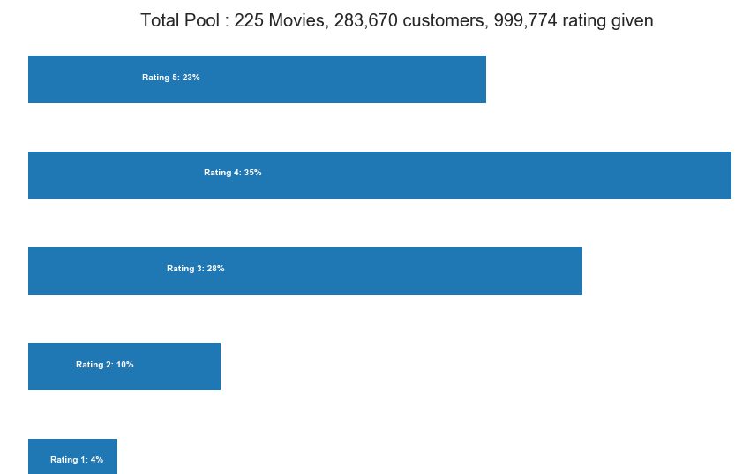

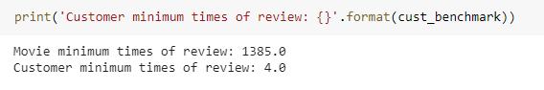

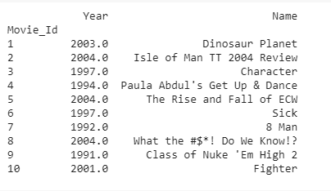

F

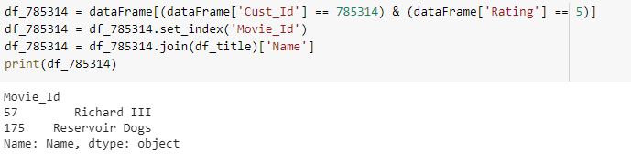

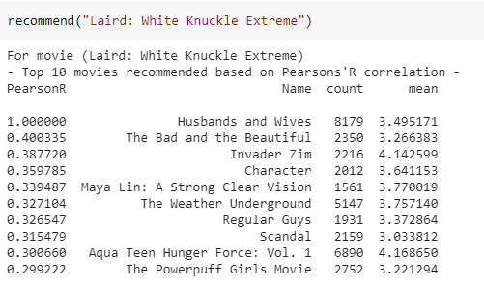

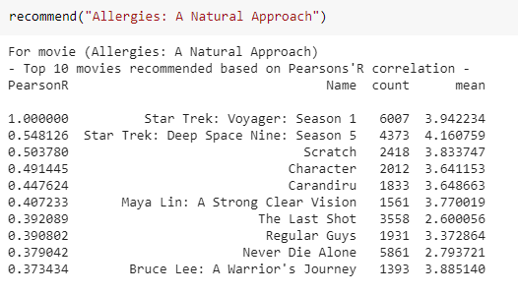

FUTURE WORK
The current model can be expanded to build a recommendation system for the entire dataset of 100 million records and all the 17000 movies by using a powerful computer with a GPU.
During exploratory analysis, we found out that the dataset not only contains movies but also TV shows. The model currently recommends both movies and TV shows without differentiating them. A flag column can be added that differentiated between movies and TV shows using which exclusive recommendations can be made. Further, we can use metadata like the actors, genres, etc.. and using matrix factorization, we can make more specific recommendations.

REFERENCES
1. https://www.kaggle.com/netflix-inc/netflix-prize-data
2. https://www.kaggle.com/netflix-inc/netflix-prize-data
3. Netflix Investor Relations, “Netflix Company Profile”, URL:https://ir.netflix.com
4. Schwartz B. (2015), “The Paradox of Choice: Why More Is Less”. Harper
Perennial, New York, NY.
5. Sarwar et al. (2001), “Item-Based Collaborative Filtering Recommendation Algorithms”

